# Java programming I

Abstract – Interface – Polymorphism

Lab Guide 5

# Session Objectives

*In this session, you will be practicing with*:

## Creation and using interface

## Creation and using abstract class

## Polymorphism

**Exercise 3** Applying polymorphism (30 minutes).

*The following code and video shows how to to use polymorphism*

***Scan and retype the code below and in video. Discuss with your class mate or instructor.***

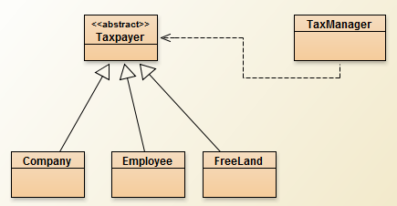

| public abstract class Taxpayer{  private String id;  public String getId(){  return id;  }  public abstract double pay();  } |
| --- |

| public class Company extends Taxpayer  {  public double pay(){  return 1000;  }  } |
| --- |

| public class Company extends Taxpayer  {  public double pay(){  return 1000;  }  } |
| --- |

| public class FreeLand extends Taxpayer  {  public double pay(){  return 10;  }  } |
| --- |

| public class Employee extends Taxpayer  {  public double pay(){  return 100;  }  } |
| --- |

| public class TaxManager {  private static final int MAX = 100;  private Taxpayer[] list = new Taxpayer[MAX];  private int count = 0;  public boolean addTaxpayer(Taxpayer taxpayer) {  if (count >= MAX) {  return false;  }  list[count++] = taxpayer;  return true;  }  public double getTax() {  double sum = 0;  for (int i = 0; i < count; i++) {  //method pay is polymorphic because we do not   // know exact object is instance of which class  sum += list[i].pay();  }  return sum;  }  } |
| --- |

## Part 2 – Lab Assignment (60 minutes)

Do the following assignments. Discuss with your class-mates and your instructor if needed.

**Exercise 1:** Write a program with has design as shown bellow

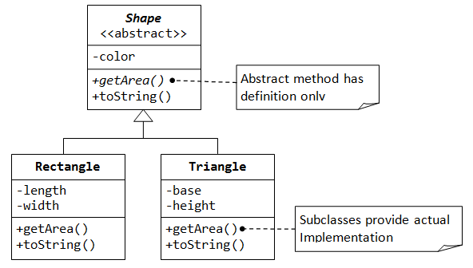

Derive two subclasses named Rectangle and Triangle from the abstract class Shape. Two subclasses must implement abstract methods getArea() declare in Shape class. Write another class called TestShape with main() method for testing Rectangle and Triangle class.

**Exercise 2**: **:** Write a program with has design as shown bellow

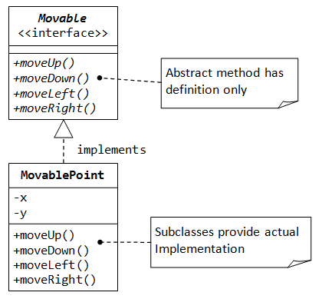

The class MovablePoint is implement the Movable interface and and provide their own implementation to the abstract methods defined in the interface Movable. In the Movable class, when moveUp() is called, that is y++, moveDown() is called, that is y-- . And similarly for moveLeft() and moveRight()

**Exercise 3:**  Write a program that has design bellow

